DIRECTIONAL RILLING SERVICES PROFILE
GOX Drilling is a business unit of GOX Energy, an incorporated Nigerian oil and gas services company with operational base at Km 3 Igbo Etche Road, Off East- West Road, by Eleme Junction, Port Harcourt City, Rivers State, Nigeria.
We specialize in providing directional drilling engineering services, Wellbore Surveying, drilling & completions software solutions, drilling bits supplies & tools rentals to oil and gas exploration companies.
As a company with a global orientation and 100% Nigerian owned, our objective is to combine our broad drilling experiences from different parts of the world with, superior local knowledge to provide excellent service delivery to our clients in Nigeria.
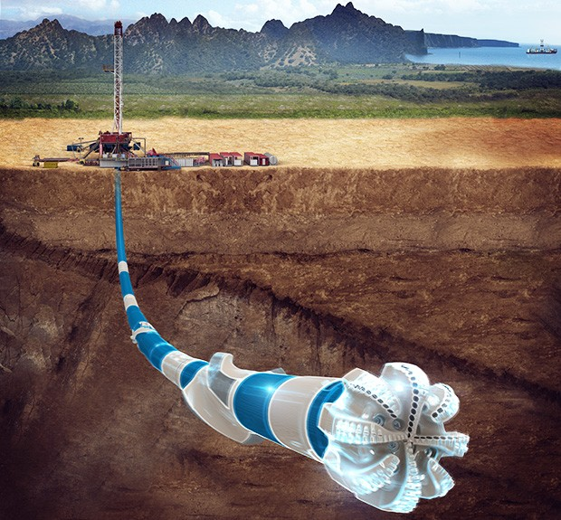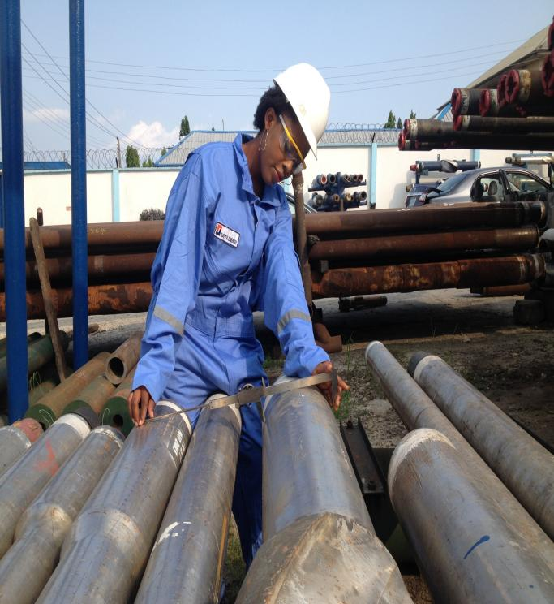
OUR CORE BUSINESS AREAS
- Directional Drilling Engineering & Consultancy

- Wellbore Surveying - North Seeking Gyro (Drop or Wireline conveyed options)

- Drilling Bits Supply, Mud Motors & Drilling Tools Rental

- Drilling Software Consulting – (WellMan & AFE Manager, PVI Software for Drilling & Completions Projects)

- NDT & UT Inspections & Drilling Equipment Procurement

- Integrated Oil and Gas Training

- Machine Shop & Drill Pipe Repairs, Drill Pipe Rethreading & Drill Pipe Re-Cutting

PORT HARCOURT OFFICE:
REVEILLE YARD @ Km.3 Igbo-Etche Road,
By Eleme Junction, Rumukwurushi
Port Harcourt, Rivers State – Nigeria.
Email: goxintl@gmail.com ; goxdrilling@gmail.com
Tel: +234 807 134 9030, +234 902 367 0870

TABLE OF CONTENT
- COMPANY
- MANAGEMENT COMMITMENT
- VISION
- MISSION STATEMENT
- CORPORATE POLICIES AND STRAGETIC OBJECTIVES
- QUALITY POLICY
6.1 PROJECT QUALITY MANAGEMENT
- HEALTH, SAFETY, SECURITY AND ENVIRONMENTAL POLICY
- IMPLEMENTATION OF POLICIES AND OBJECTIVES
- RESOURCES
- TECHNICAL CAPABILITY
- BACK-UP SERVICES
- COMPANY ACTIVITIES
  - DIRECTIONAL DRILLING CONSULTANCY, GEOSTEERING, L/MWD
  - WELLBORE GYROSCOPIC SURVEYING
  - DRILLING BITS SUPPLY & DRILLING TOOLS RENTAL
  - SOFTWARE CONSULTANCY – WELLMAN FOR DRILLING & COMPLETIONS
  - WELL TESTING & WELL HEAD MAINTENANCE
  - MACHINE SHOP – DRILL PIPE & CASING PIPE RE-CUTTING / RE-THREADING
  - PROCUREMENT – O&G, PETROCHEMICAL, CIVIL EQUIPMENT
  - NDT INSPECTION
- FACILITIES
- CLIENTS
- WORK PROCEDURE
  - SCOPE OF WORK
  - WORK PROGRAMME/TIME SCHEDULE
  - ACQUISITION OF RESOURCES
  - JOB EXECUTION
  - COMMUNICATION WITH CLIENT
- EXCEPTIONS/CLARIFICATIONS CLAUSES
  - AWARD OF CONTRACT
  - NATURAL IMPEDIMENTS
  - CLIENT’S FINANCIAL OBLIGATION
  - LIABILITIES
- CONTACT
  - OFFICE
- SOME OF THE PICTURES OF OUR FACILITIES

- THE COMPANY
GOX International is an incorporated Nigerian oil and gas services company with operational base at Km 3 Igbo Etche Road, Off East- West Road, by Eleme Junction, Port Harcourt City, Rivers State, Nigeria.
We specialize in providing directional drilling engineering services, drilling & completions software solutions, Well Testing, Well Head Maintenance and drilling bits & tools rentals to oil and gas exploration companies.
As a company with a global orientation and 100% Nigerian owned, our objective is to combine our broad drilling experiences from different parts of the world with, superior local knowledge to provide excellent service delivery to our clients in Nigeria.
We are striving to build a one-stop-shop for all directional drilling needs in the industry especially in the area of drilling bits, drilling tools and pipes supplies and rentals, we still stand out as the one of the indigenous company in the field that started from the scratch with only local personnel and delivering world class quality services which is evident in our fast growing customer base.
GOX services are offered through a number of dedicated, high skilled engineers and technicians capable of providing custom designed solutions for each specific problem relevant to Oil, Energy, Gas Exploration and Exploitation relative to directional drilling, well testing, drilling software and drilling tubular repairs / machine shop. It can virtually supply unlimited resources provided by each of the many supporting companies.
GOX INTERNATIONAL NIGERIA LIMITED operational Base/Workshop is located at Km. 3, Igbo-Etche Road, By Eleme Junction, Port Harcourt, Rivers State, Nigeria, occupying about 12,000 Square Meters of yard area including Offices, Warehouse/Machine Shop, pipe racks and storage areas.

Our principal contact details are:
Phone Numbers: 0807 134 9030 - Operations Director - OGU Charles Ekene
0802 305 5808 - Technical Director - DEJI Kareem Wasiu
0803 226 3846 - Sub Surface Director - OKILIKA Mike Ijachi
0803 899 0949 - Workshop Manager - OKPARA Ikemba

E-mail goxintl@gmail.com; goxdrilling@gmail.com

- MANAGEMENT COMMITMENT
The management of GOX INTERNATIONAL NIGERIA LIMITED is well focused in prompt execution of jobs and quick provision of efficient and optimal services for her valued clients.
Our well mapped – out procedures and strategies for efficient job execution are backed up with properly guided policies and objectives, which are strictly adhered to.
Also our management team is geared towards continual improvement in standard and professional ethics and values in machine shop and fabrication services, bringing to play practicable management principles.
We appreciate your patronage.

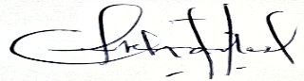
OGU CHARLES EKENE
Sign._____________________________________________________________________ (MD/C.E.O)
10th January 2026
Date:_____________________________________________________________________

- VISION
Our vision is to meet up with the present and future request/need of the Oil, Gas, Energy and Allied Industries in Nigeria.
- MISSION STATEMENT
Our mission is to be introduced and recognized as one of the best country’s leader in all our specific areas of activities.
In pursuance of this vision and mission,
OUR THINKING
Is guided by these principles:
- Top quality services to our clients.
- Competency.
- Continuous review of quality in technical profile.
- Optimum value on our human assets and the environment.
- Consistent building of trust and accountability.
- Conducting business with the highest ethics and integrity.
- CORPORATE POLICIES AND STRATEGIC OBJECTIVES
It is the policy of GOX INTERNATIONAL NIGERIA LIMITED to carry out its drilling support and tool rental services in an ethical and socially responsible manner that guarantees efficient, effective, safe, cost – effective and quality provision of good hygiene, environmental aesthetic and standards that meet the precise prescription of our client and host community.
Our strategic objectives include but not limited to the following:
- to ensure zero (0) fatality.
- to provide at all times excellent, quality and acceptable environmental safety services to all stakeholders, investors, clients, communities, staff and the general public.
- To take pro–active measures that brings creative and innovative services to our clients and host communities.
- To ensure strict compliance to environmental and safety policies and standards during operation.
- To recruit, train and deploy highly specialized, skilled and professional personnel that can compete favorably with regards to all our services.
- QUALITY POLICY
Keen on excellence to our customers, our service deliverables must be consistently of the highest quality obtainable. We ensure that our customers’ needs are met and exceeded, where possible, demonstrating our professionalism and experience in our areas of operations. Quality is the commitment of every one in GOX INTERNATIONAL NIGERIA LIMITED.
These quality objectives shall be achieved through:
- Prompt provision of information and/or services to our clients.
- Priority attention to customer satisfaction through articulated consideration and conformation of customers’ needs and expectations.
- Create a conducive working environment for our employees through:
- Commitment to quality.
- Mutual trust, respect and love.
- Team work.
- Continual improvement.
- Compliance with National and International Standards (Health, Safety and environmental protection regulations).
- Recognition and celebration of individual or team achievements or innovations to our business processes.
- Measure the efficiency of our processes and ability to meet our customers’ requirements and expectations.
- Accept only work for which we have the competence and professionalism.
- Help employees identify, pursue and improve the quality of their work and optimize company resources to achieve optimum quality.
- Identify shortcomings and take necessary corrective actions promptly.
- Ensure adequate communication interface with customers to identify complaints before they become problem.
- Treat our customers as partners in progress.

  - PROJECT QUALITY MANAGEMENT
Our operations are carried out in compliance with the ISO 9001 Quality Management System standards. We are therefore capable of using experience to ensure projects are executed in accordance with established quality management principles and systems. This gives confidence that service deliverables are not only achieved but meet customer’s requirements and specifications on schedule. We shall establish or cause the contractors to establish a project quality plan consistent with owner’s operations, procedures and owner’s quality organizations.
- HEALTH, SAFETY, SECURITY AND ENVIRONMENTAL POLICY
GOX INTERNATIONAL NIGERIA LIMITED is committed to pursuing the policy of no harm to people, protecting the environment. Acting as a role model in promoting best practices in the industry, managing HEALTH, SAFETY, ENVIRONMENTAL and SECURITY matters to the standard expected in accordance to lay down principles and code of conduct for business activities. Promoting an essential method to support a sustainable development and in this way earn the confidence of our esteemed customers, shareholders and entire society.
- The above policy is fully implemented to achieve a continuous improvement.
- Comply with all relevant legislation and regulation.
- Set targets for improvement and measure appraise and report performance.
- Interact with her customers and shareholders for feedback and improvement.
- Using available materials and energy efficiently and minimizing waste.
- IMPLEMENTATION OF POLICIES AND OBJECTIVES
The management of GOX INTERNATIONAL NIGERIA LIMITED shall be directly involved in effective implementation of set policies and objectives.
- Communicating Policies and Objective statement to all staff at different levels of job operations in a way they will easily understand.
- Mandating all staff working in the establishment to know his/her role in carrying out the policies.
- Renewal of these policies and objectives periodically to ensure their continuity and suitability in environmental monitoring and safe environment upkeep.
- Periodic setting of operational goals and targets for the performance/evaluation of the staff.
- Application of internal control measures.
- Strict supervision to ensure compliance with regulatory and legislative standards.
- Documentation of processes, activities and results for performance measurement and corrective actions.

- RESOURCES
GOX INTERNATIONAL NIGERIA LIMITED has every handy human and material resource which exists in form of: infrastructure, working environment, finance, certified skill personnel, technological know-how, information flow, adequate working capital, establishing quality policy, objectives and tendency to review our quality management system.
We have very high technical, practical and professional caliber of personnel. We have not only consumable expertise, but worked as a team long enough to guarantee fluidity of operations and success.
- TECHNICAL CAPABILITY
GOX INTERNATIONAL NIGERIA LIMITED has a wide range of technically inclined equipment in stock that is mobilized when needed. Also a range of others permanently mounted in the office block for preparation of desired services.
- BACK-UP SERVICES
In addition to vast resources of GOX INTERNATIONAL NIGERIA LIMITED, this company also has an immense amount of resource-materials in reserve to cater for any sudden need, and as a base for quick response services. These reserved resource-materials are in form of equipment, hand tools, data, and information, among others.
- COMPANY ACTIVITIES
GOX INTERNATIONAL NIGERIA LIMITED offers following services to the Oil and Gas, Energy and Allied Industries:
- Directional Drilling Engineering, Geo-Steering & Well Placement

- Wellbore Surveying - North Seeking Gyro (Drop or Wireline conveyed options)

- NDT & UT Inspection

- Drilling Bits Supply Mud Motor & Drilling Tools Rental

- Software Consulting – (WellMan & AFE Manager for Drilling & Completions Project Reporting)

- Procurement – Drilling, Petrochemical, Civil & Agricultural equipment
- Machine Shop - Drill Pipe Repairs, Drill Pipe Rethreading & Drill Pipe Re-Cutting Machine Shop and Fabrication Services (Threading of all API/Rotary Shouldered Connections).
  - OCTG Services (Cleaning, Hardbanding, Recutting, Rethreading, Storage)
  - Casing, Tubing, Liner, Connectors and Accessories (OCTG)
  - Rental of Drilling Tools – Drill pipes, Collars, Subs, Stabilizers, etc.
  - Rental of Fishing Tools
  - Other Drilling Services.
12. 1 DIRECTIONAL DRILLING ENGINEERING
Directional Drilling is our business and we have the capability to deliver any directional well profiles; top holes, tangent sections, curve sections, simple deviated wells, horizontal wells, extended reach wells, short and long radius wells. From spud to TD (top hole through intermediate section to target depth).

The Directional Drilling team in GOX Drilling, consistently aim to deliver high quality, low tortuous directional wells, as well as always achieve sustainable success by acting in the long-term interests of our customers. Through optimizing drilling parameters, penetration rate, bottom hole assembly and utilization of properly trained indigenous team.

The 9 5/8” mud motors in our fleet are used for drilling 12 ¼” up to 17 ½” hole sections. While the 6 ¾” muds motors are good for drilling hole sizes from 8 ½” up to 9 7/8”. Respective mud motor specifications are shown below.

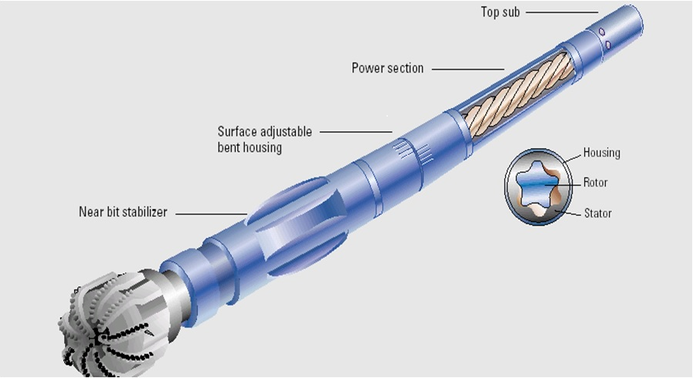
6 3/4” MUD MOTOR SPECIFICATIONS
Size 6 ¾” ”
Hole Sections 8 ½” – 9 7/8”
Lobe Configuration 7/8
Stage Length 5.0
Stator Rubber Type Power Plus
Operating Max Diff. Pressure 1050 psi
Operating Flow Range 300 – 600gpm
Revs per Unit Volume 0.29 RPG
Top Drives Speed 80 – 174 RPM
Torque @ Max. Pressure 8959 ft-lbs
Top Connections 4 ½” API Regular
Bottom Connection 4 ½” API Regular
Operating BottomHole Temp. 273 deg F (100 deg C)
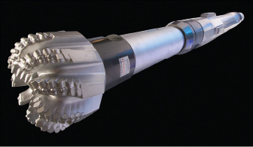
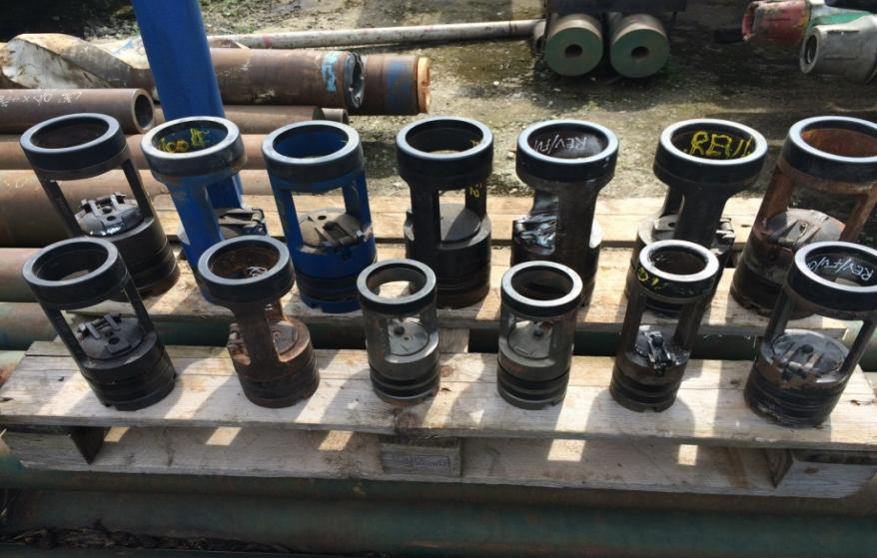

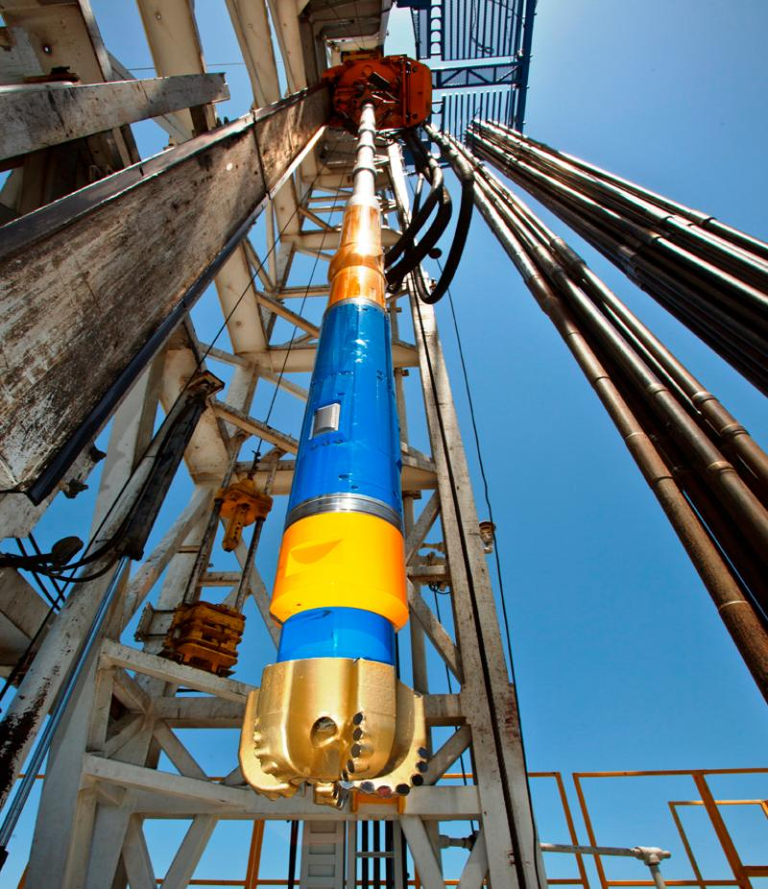
9 5/8” MUD MOTOR SPECIFICATIONS
Size 9 5/8”
Hole Sections 12 ¼” – 17 ½”
Lobe Configuration 7/8
Stage Length 4.8
Stator Rubber Type Power Plus
Operating Max Diff. Pressure 1050 psi
Operating Flow Range 600 – 1200gpm
Revs per Unit Volume 0.12 RPG
Top Drives Speed Range 70 – 139 RPM
Torque @ Max. Pressure 22386 ft-lbs
Top Connections 6 5/8” API Regular
Bottom Connection 7 5/8” API Regular
Operating Bottom Hole Temp 273degF (100degC)

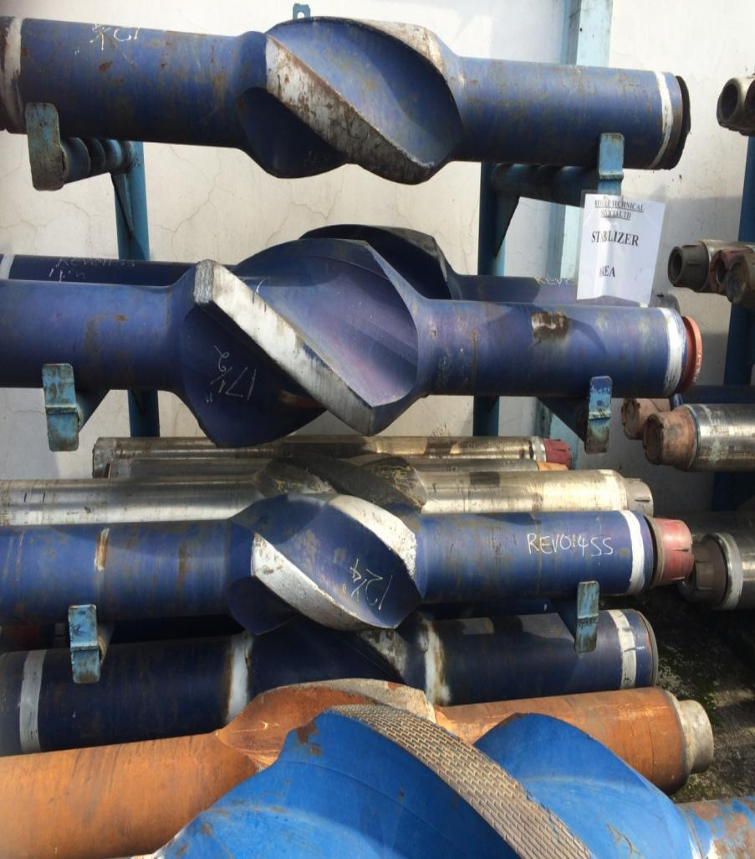

We work with our clients from Well Planning & Borehole Trajectory Design, through BHA & Bit Selection, to successfully execution of directional wells at the rig site. This close approach system is supported and accomplished by experienced management and field team, commitment to safety and high standards of service quality.

Additionally, our Directional Drilling Engineers have cumulative of over 60 years experience working on the for major international directional drilling companies delivering wells for all major producing and explorations companies in Nigeria and overseas. Equally, they have obtained numerous training certifications from best-in-class directional drilling training centers in the world.
Our goal is to minimize drilling time, penetrate faster to the pay zones and deliver a high quality directional wells for our clients at all times.

12.2 WELLBORE GYROCOPIC SURVEYING

GyroTracer
Overview: The GyroTracer instrument is a highly accurate, extremely reliable downhole directional survey and
orientation tool. Comprising of the latest technology, the system uses gyro compassing method to find direction. As it is a
North Seeking Gyro, all measurements are in reference to geographic north. Unlike other downhole survey or magnetic
tools, the GyroTracer is not affected by magnetic interference. It can be run inside casing, tubing, drill pipe and
magnetically disturbed ground.
This 42mm diameter, easy to use system can be run in a variety of applications from shallow borehole to deep borehole
surveying, single shot/multi shot, slim hole casing, orientation, whip stock kick‑off and downhole motor orientation.
Operating software to run all instruments is very reliable and user friendly. The GyroTracer package comes with both
wireline and memory mode option. Wireline mode is run from an electric line cable transmitting real time data to the
computer at the surface. Mono or multiple conductor cable can be used. Memory mode is fast and cost efficient as this is
powered by battery supply and run on slick line.
Features and benefits
• Not affected by magnetic interference
• No field calibration or roll test required before each survey
• Collar azimuth not required. Only latitude of hole needs to be entered into the software program
• No sight alignment is required
• No drift. Each survey is independent and not in relation to the previous survey
• Can traverse in hole at up to 120m/min
• Package includes both wireline and memory mode
• Short length, light weight tool
• User friendly software
• Very accurate and reliable
• Built inside high grade titanium pressure barrel
• No other running gear required
• Rugged design
• Minimal downtime as all operating equipment and software is very reliable
• All azimuth measurements are in reference to geographical north
• Export all your survey data to Excel and other formats
Specifications
• Gyrocompassing survey time of 55 seconds
• Azimuth accuracy of +/‑ 1.0° in inclination range from 1.0° ‑ 70.0° (from vertical)
• Repeatability in azimuth +/‑ 0.5°
• Inclination accuracy of +/‑ 0.1°
• Gravity toolface accuracy of +/‑ 0.1°
• Gyroscopic toolface accuracy of +/‑ 1.0° in inclination range from 0.0° ‑ 1.0° (from vertical)
• Temperature rating : ‑ 30°C to +100°C (‑22°F to +212°F)
• Pressure rating: 103Mpa (15.000psi)
• Dynamically tuned mutli‑axis close loop gyroscope
• Quartz technology accelerometers
Dimensions
• OD 42 mm (1.65”)
• Wireline mode Length= 2300 mm (90,55), Memory mode Length= 2000 mm (78,74”)
• Weight 15 kg (33,07 lb)

DROP- Gyro (Free fall)

Accuracy: Dependant on wellbore profile
Typ Azimuth Accuracy: 0.5°
SPE WPTS (ISCWSA) error model available on request
Instrument OD: 1.3” (33mm) 1
Instrument Length: 33” (838mm)
Pressure Cased OD: 1.75” (without thermal shield)
Pressure case length: 40”min
Pressure Rating: 20,000psi
Operating modes: Wireline or battery Orientation, survey, memory multishot Continuous survey readout at
wireline speeds up to 300 ft/min
Memory Capacity: 3,000 shots in multishot / Drop mode
Battery Life: Up to 20 hours (programmable hold off, shot interval)
Drop Mode: Freefall drop (Go-Devil), drill string retrieved
Wireline Telemetry: Digital, Mono or multi conductor to 30,000 ft
Depth Measurement: Auto continuous depth measurement available
Wireline Supply: 125mA Constants current at 30v
Max Power Consumption: 3 Watts
Temperature: 32-400°F(200°C) with thermal shield for up to 8 hours
40-200°F (without thermal shield)
Shock: 1,000g, 1/2 sine 1mS
Vibration: 10g rms, 20-1,000Hz random
Surface
Equipment
Wireline Power Supply: 110/240v AC in, 200w Out with protection
Rig Floor Display: 256 x 128 Transflective LCD with backlight Sealed to IP65
Sensor: State-of-the-art tri-axial gyroscopes - High accuracy tri-axial accelerometers

12.3 DRILLING SOFTWARE SOLUTIONS – WELLMAN, AFE MANAGER, DATA VISUALIZATION

WELL PLANNING AND TRAJECTORY DESIGN
We currently use Landmark COMPASS for Anti-collision monitoring, Hydraulic / Torque & Drag Stimulation and analysis. And WELLPLAN for wellbore trajectory design, trajectory control and monitoring and survey management. Our daily reports are delivered in comprehensible and detailed format that is very reader friendly. Minimum of two operational drilling reports containing survey updates, run parameters, observations and recommendations are submitted to the client’s Drilling Engineers and/or Drilling Supervisors each day or as operations demand.

REPORTING SYSTEM
Our Engineer’s utilize WELLMAN NextGen, for all daily operational, cost, equipment inventory, personnel & material reporting and update. This software automatically saves all data input in a secured repository database/server resided in USA. Data are transmitted in an encrypted format to ensure maximum data security. Authorized client’s engineers will have access to archived data or real time field operational update any time of the day, from anywhere in the world as long as they have access to internet connections.
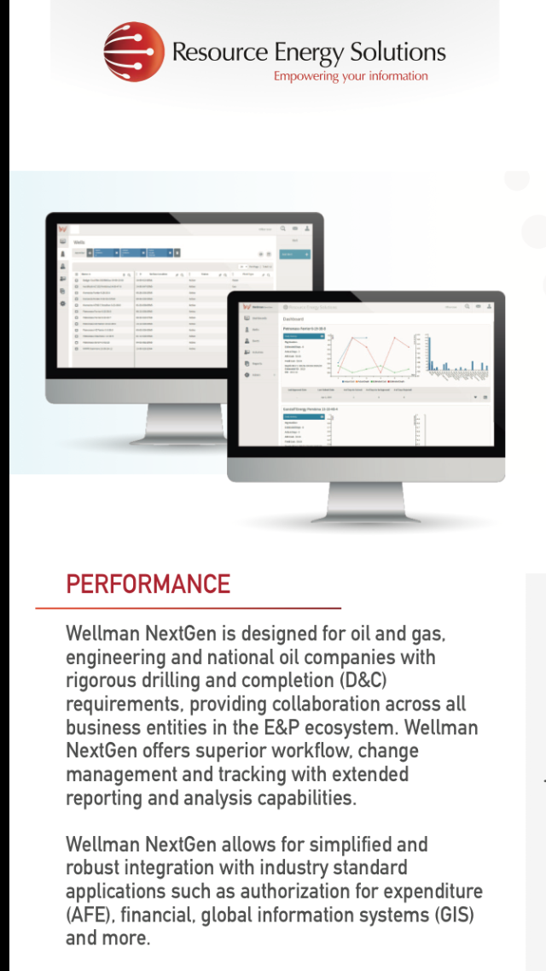
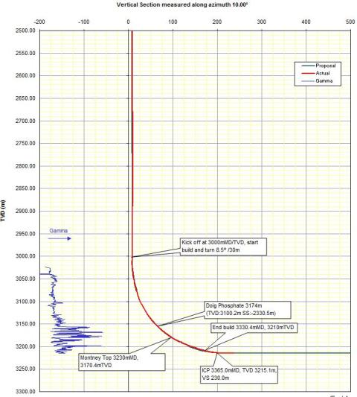
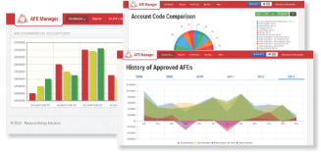

This very robust and very powerful field reporting system, comes in handy and helps field / office based engineers carry out offset correlations on the fly with minimal time wastage when information from old wells/fields are needed for resolving doubts /drilling challenges. It also enhances data accuracy for KPI computations and during auditing. A screen shot of how drilling reports gets to our client’s desk is shown herein.

SOME OF THE SOFFTWARE PRODUCTS OFFERED FOR DRILLING, CEMENTING, TUBULAR RUNNING ETC.

PRODUCT GROUP | OPERATIONS | SOFTWARE
DRILLING OPERATIONS | Torque and Drag | TADPRO
DRILLING OPERATIONS | Torque, Drag and Hydraulics | DEPRO
DRILLING OPERATIONS | Drilling Hydraulics | Drilling Hydraulics
DRILLING OPERATIONS | Surge Pressure | SurgeMOD
DRILLING OPERATIONS | Casing Design Expert | CDEx
DRILLING OPERATIONS | Circulation Temperature | CTEMP
DRILLING OPERATIONS | Underbalanced Drilling Hydraulics | UBDPRO
DRILLING OPERATIONS | Stuck Pipe Analysis | StuckPipePro
DRILLING OPERATIONS | Bridging Agent Sizes | PlugPRO
MUD REPORTING | Drilling Mud Reporting | MUDPRO
WELLBORE CLEANUP | Wellbore Cleanup | CleanMax
CASING WEAR | Casing Wear Prediction | CWPRO
CEMENTING | Centralizer Placement | CentraDesign
CEMENTING | Cement Lab Data Management | CEMLab
CEMENTING | Cementing Engineering Toolbox | CEMVIEW
CEMENTING | Mud Displacement | CEMPRO
CEMENTING | Cement Plug Placement | PlugPRO
CEMENTING | Cement Stress Model | CEMLife
DRILLING ENGINEERING | Drilling Engineering Toolbox | Dr. DE
WELL TRAJECTORY VIEW | Well Path Visualization | PathView
TUBING RUNNING | Tubing Movement | TMPRO
SPLIT FLOW HYDRAULICS | Split Flow Hyraulic Anayleses | SplitFlow

12.4 DRILLING BITS & DRILLING TOOLS RENTAL

GOX Drilling supplies all types of drilling & hammering bits, ranging from tricone bits, PDC (Polycrystalline Diamond Cutters. We are Nigerian representatives of South Korean “KT&I Hamering Bits.

Drilling Tools Rental division of GOX Drilling (Reveille Oil & Gas) has being providing drilling and fishing tools rental & leasing services since 2009. Our clienteles include: multi-nationals, nationals, marginal operators and independent oil and gas drilling companies located all over Nigeria.

Listed below are some of oil & gas well drilling tools in our inventory for rentals, more options are available:

- String Stabilizers (Steel & Non Magnetic) 5 ½”- 36”
- Non Magnetic Drill Collars (NMDC) 4 ¾” - 9 ½”
- Cross-Over Subs (Steel & Non Magnetic) 4 ¾” - 9 ½”
- Universal Bottom Hole Orientation Subs (UBHO) 4 ¾” - 9 ½”
- Non Magnetic Pony Collars 4 ¾” – 9 ½”
- Non Magnetic Flex Collars 4 ¾” – 8 ½”
- Drill Pipes 2 ^{7/8}” – 6 ^{5/8}”
- Drill Collars (Steel)
- Hevi Weight Drill Pipes (HWDP)
- Float Subs & Float Valves
- Bumper Subs
- Bits – Various sizes
- Circulating Subs
- Side Entry Subs
- Fishing tools

Note: We can create affordable plans for drilling tools rentals that meets our customer’s needs and also within budget.

12.5 INTEGRATED DRILLING PROJECT MANAGEMENT CONSULTANCY & PROCUREMNET

GOX Drilling is excited to introduce Integrated Drilling Project management Consultancy services through our local service companies.

We have partnered with some local and well established oil and gas service companies to offer integrated project management consultancy services in areas of field development from site preparations through, drilling, casing and completions stages.

This will serve as a one stop shop for field developments, drilling, fluid, casing, and cementing operations.

Our years in O&G industry has offered us opportunity to understand the intricacies of drilling operations and we will be glad to assist our prospects / clients meet their drilling project needs. Our Team of Drilling & Completion Engineers will be glad to attend to your drilling challenges.

12.6 MACHINE SHOP
Machine shop unit of GOX (REVEILLE OIL & GAS), specializes in the cutting and re-cutting of all types and sizes of API/Rotary shouldered connections (Threads) e.g. Internal Flush (IF), Regulars (Reg), Full Hole (FH), EUE, STC etc on Drill pipes, Collars, Subs, Casing, tubings and stabilizers.
We are duly certified and licensed by the American Petroleum Institute (API) to carry out these services. Our certificates and numbers are as follows for your verification.
1. API Specification Q1 - Q1-2564
2. API 7 – 1 - 7-1-1229
3. API 5CT - 5CT-1752
4. ISO 9001 : 2015 - 2709
We have a wide range of original API Guages to cut the following sizes of these threads.
1. 2 3/8” IF 3 ½” FH 2 3/8” REG 1 ½” EUE
2. 2 7/8” IF 4 ½” FH 2 7/8” REG 2 3/8” EUE
3. 3 ½” IF 5 ½” FH 3 1/2” REG 2 7/8” EUE
4. 4” IF 6 5/8” FH 4 ½” REG 3 ½” EUE
5. 4 ½” IF 7 5/8” REG 4 ½” EUE
6. 4 ½” LTC OR STC - 13 3/8”
7. 4 ½” BTC – 13 3/8”.

The company also imports the 4145H material for the manufacture of all sizes of Subs (X-Overs, bit Subs, Saver Subs, Float Subs, etc) to any specification as the client might require.
We also provide general machining and machine shop services apart from API threading, e.g, machining of steel parts and other modifications.
Our prices are very moderate and further discounts are available as volume of jobs increase. The price list of our standard threading services can be forwarded at your request.
12.7 TOOL RENTAL SERVICES
GOX in partnership with sister company, Reveille Oil has a Tool Rental section with a wide variety of both drilling and fishing tools available for rentals and outright sales as the client might require.
Our prices are very competitive and further discounts are also available as the volume of rentals increase.
Our Machine shop is readily available to support the rental section to ensure that tools are always ready to go even at very short notices; turnaround time is also reduced as tools coming back from rentals are quickly readied for another job.
Also our rental clients also enjoy a huge discount on post-rental repairs since these repairs are done in-house.
- CLIENTS
- Halliburton Energy Services Ltd  - Sterling Energy and Exploration Compoany (SEEPCO)  - NOV Oil & Gas Services Limited  - DWC Drilling Nig Ltd  - WEATHERFORD Nig Ltd  - Wellsmart Drilling Nigeria Ltd  - WOG Allied Services Ltd | - Drillog-Petro-Dynamic Ltd  - Geoplex Drilltech Ltd  - Segofs Energy Services Ltd  - Green Stone Nig. Ltd  - Unitech Drilling  - Tobitem Downhole Services Ltd  - Dreck Integrated Services Ltd  - Deptwize Nigeria Limited

14.1 SCOPE OF WORK
GOX INTERNATIONAL NIGERIA LIMITED shall endeavor to establish the scope of work in reference to financial, material and human requirements.
14.2 WORK PROGRAMME/TIME SCHEDULE
GOX INTERNATIONAL NIGERIA LIMITED shall set out appropriate work programme/time schedule to guide its services.
14.3 ACQUISITION OF RESOURCES
GOX INTERNATIONAL NIGERIA LIMITED shall proceed to acquire the necessary resources that will enable it to execute the contracts or fulfill its contractual obligations to the satisfaction of its clients.
14.4 JOB EXECUTION
GOX INTERNATIONAL NIGERIA LIMITED shall embark on all necessary activities that will lead to the successful discharge of the contract in strict compliance with the contract terms as spelt out in the contract agreement.
14.5 COMMUNICATION WITH THE CLIENT
GOX INTERNATIONAL NIGERIA LIMITED shall endeavor to establish an efficient and effective communication channel with its clients to enable the free flow of information to and from its clients as may be necessary for the successful execution of the job. Also, all communication shall be in writing.
- EXCEPTIONS/CLARIFICATION CLAUSES
In the course of discharging its contractual obligations, GOX INTERNATIONAL NIGERIA LIMITED wishes to state the following exceptions/clarifications clauses:

16.1 AWARD OF CONTRACT
All contract awards shall be in writing duly signed by an authorized representative of our client.
16.2 NATURAL IMPEDIMENTS
GOX INTERNATIONAL NIGERIA LIMITED may be incapable of discharging its contractual obligations due to the occurrence of natural disasters and impediments beyond her control such as flooding, earthquake, government action, etc.
16.3 CLIENT’S FINANCIAL OBLIGATIONS
GOX INTERNATIONAL NIGERIA LIMITED its financial obligations as expressed in the contract agreement but may make necessary concessions as may become mutually convenient for the discharge of the contract.
16.4 LIABILITIES
GOX INTERNATIONAL NIGERIA LIMITED shall be absolved of all liabilities due to any cause that it has no direct responsibilities or obligations. Such incidences shall however be immediately communicated to our client for appropriate resolutions thereof.
17.0 CONTACT & OFFICE ADDRESS
(REVEILLE Yard) Km. 3 Igbo-Etche Road
Rumukwurushi Town, By Eleme Junction
Port Harcourt, Rivers State — Nigeria
Tel: 0807 1349030, 081 955 5895, 0803 938 3666, 0803 899 0949
E-mail: goxintl@gmail.com; goxdrilling@gmail.com

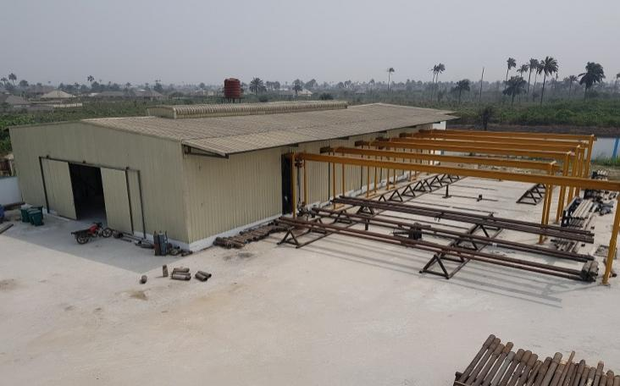
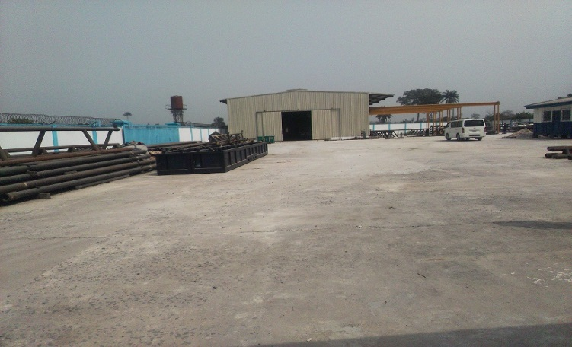
18. SOME OF THE PICTURES OF OUR FACILITIES
Aerial View of the Machine Shop Operations base view from the entrance gate
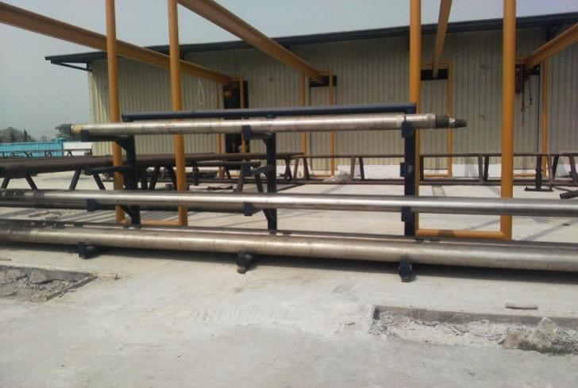
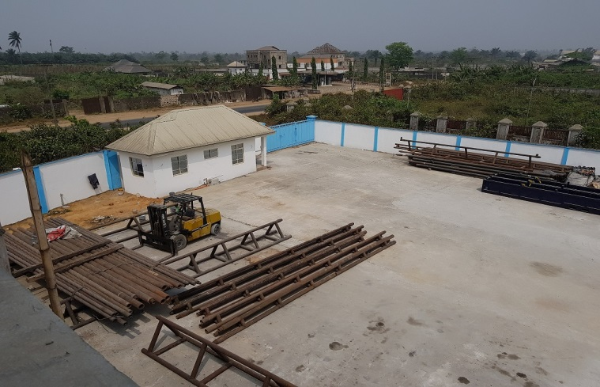

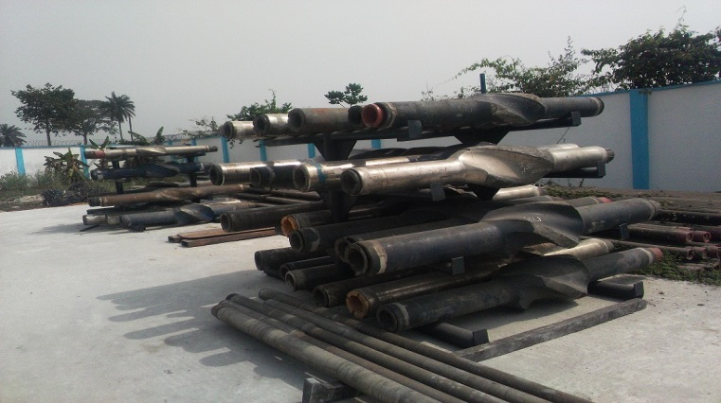
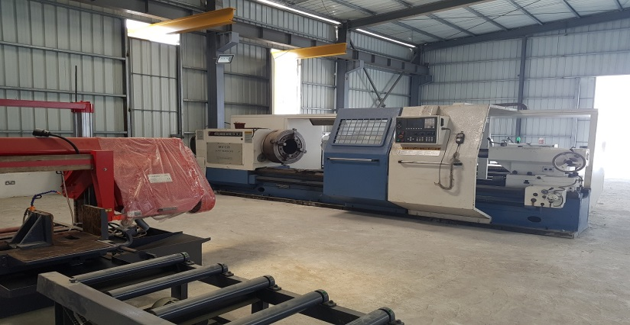
Aerial View – Security Gate/Pipe Rack Aerial View – Security Gate/Pipe Rack
Torque Master Break Out Machine Drilling Tools Rack

Our Foreign Partners


Resource Energy Solutions (RES), Canada
- AFE Manager – Cost & Asset Management and Control
- WellMan – Infield Drilling & Completions Reporting
- SaaS - Mining & Construction Management Software

K&T Hammer & Bit Corp., South Korea
- Drilling Bits
- Mining Bits
- Percussion Hammer Button Bits
1)

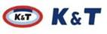
2)

3)  PVI Softwares, Houston, Texas

Summary

We guarantee that, when you give us a job - you go to sleep, as our Directional Drilling Engineers have cumulative of over 150 years of on-the-rig experience. We have worked for major international directional drilling, bit manufacturing and wellbore surveying service providers. We have delivered wells for numerous IOCs in Nigeria and overseas. Additionally, our Engineers have obtained numerous training certifications from some of the best-in-class directional drilling training centers in the world.

Our goal is to optimize drilling time, penetrate the pay zones faster and deliver a high-quality well for our clients at all times.

